**Project Design Phase-II**

**Technology Stack (Architecture & Stack)**

|  |  |
| --- | --- |
| Date | 31 January 3035 |
| Team ID | LTVIP2025TMID60699 |
| Project Name | Sustainable Smart City Assistant Using IBM  Granite LLM |
| Maximum Marks | 4 Marks |

**Technical Architecture – Sustainable Smart City Assistant**

**This section outlines the technical structure of our Smart City Assistant. The system is built using modular architecture with distinct layers for user interaction, logic processing, AI-based services, and data retrieval from external APIs. The backend integrates IBM-deployed models, and the frontend is powered by Streamlit for lightweight, reactive UI rendering.**

**System Flow Overview**

1. **User interacts with the assistant through the dashboard, chat interface, and alerts.**
2. **The frontend is built using Streamlit and JavaScript-based components.**
3. **User actions trigger backend processes — data fetching, summarization, forecasting, anomaly detection, and tips generation.**
4. **The system also calls APIs (e.g., AQI, weather) and uses a deployed IBM model for advanced ML tasks like anomaly classification and eco-behavior modeling.**
5. **The processed output is shown via dashboards, chat replies, smart alerts, and summaries.**

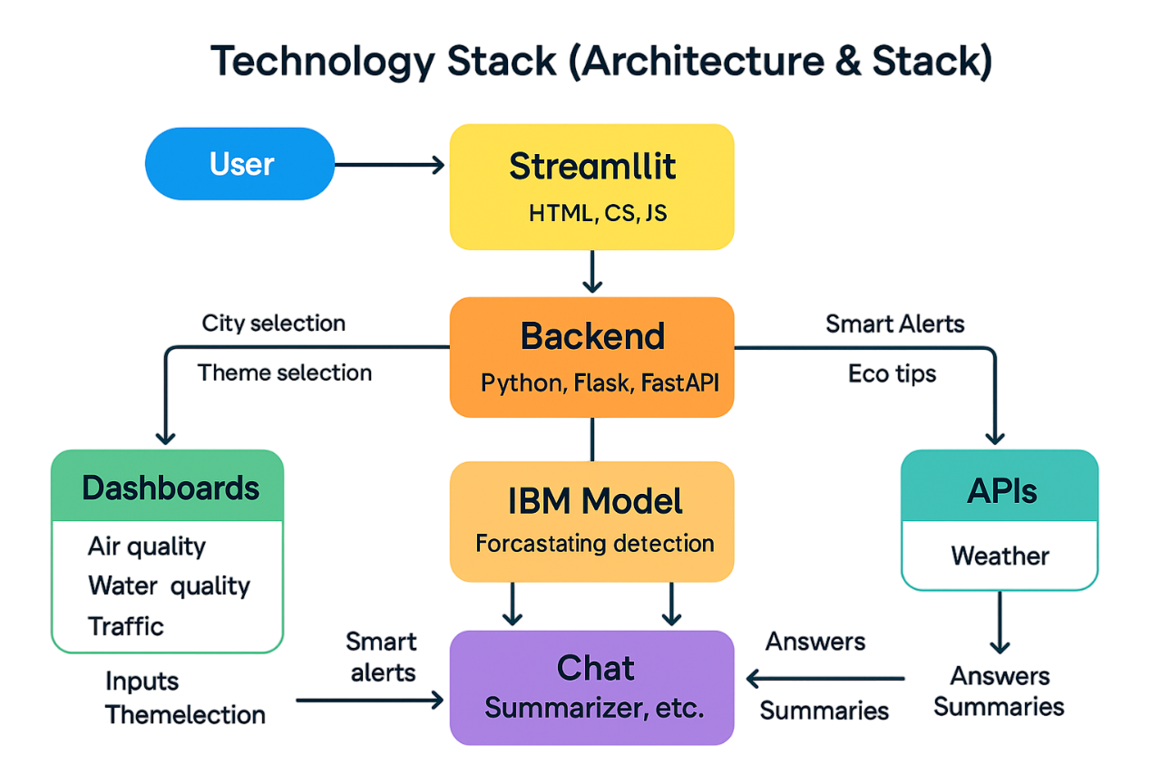

**Table-1: Components & Technologies**

|  |  |  |  |
| --- | --- | --- | --- |
| **S.No** | **Component** | **Description** | **Technology** |
| **1** | **User Interface** | **Web-based dashboard, chat interface, alert widgets** | **Streamlit, HTML, CSS, JS** |
| **2** | **Application Logic-1** | **Core logic for data visualization and dashboard updates** | **Python (Pandas, NumPy, Plotly)** |
| **3** | **Application Logic-2** | **ML logic for forecasting and anomaly detection** | **IBM Cloud ML Model (deployed model endpoint)** |
| **4** | **Application Logic-3** | **Chat logic and summarization service** | **Python, OpenAI GPT model (or fallback rules)** |
| **5** | **Database** | **Temporary session storage (if needed)** | **Local JSON storage or lightweight SQLite** |
| **6** | **Cloud Database** | **For future expansion** | **Firebase / IBM Cloudant (optional)** |
| **7** | **File Storage** | **Eco tips, summaries, city data configs** | **JSON Files on local file system** |
| **8** | **External API-1** | **Real-time AQI and environmental data** | **AQI India API, OpenWeatherMap** |
| **9** | **External API-2** | **Weather & city coordinates** | **OpenWeather API / LocationIQ (optional)** |
| **10** | **Machine Learning Model** | **Forecast AQI/water/traffic + detect anomalies** | **IBM Deployed Time-Series ML Model** |
| **11** | **Infrastructure** | **Hosted locally for demo; cloud-ready** | **Localhost / Firebase Hosting / IBM Cloud** |

**Table-2: Application Characteristics**

|  |  |  |  |
| --- | --- | --- | --- |
| **S.No** | **Characteristics** | **Description** | **Technology Used** |
| **1** | **Open-Source Frameworks** | **Tools used for rapid development and data display** | **Streamlit, Python, Flask, Scikit-learn** |
| **2** | **Security Implementations** | **API keys securely handled; no personal data stored; HTTPS enforced** | **Environment variable handling, CORS setup** |
| **3** | **Scalable Architecture** | **Modular layout: UI, logic, ML, API — easily extendable to more cities & users** | **Microservices-ready, Serverless architecture** |
| **4** | **Availability** | **App accessible 24x7 if hosted online, with fallback for offline city data/tips** | **Firebase Hosting / Streamlit Cloud** |
| **5** | **Performance** | **Pre-cached metrics; asynchronous API calls; minimal data load per request** | **Python caching, low-latency API use** |